Exceptions in Java

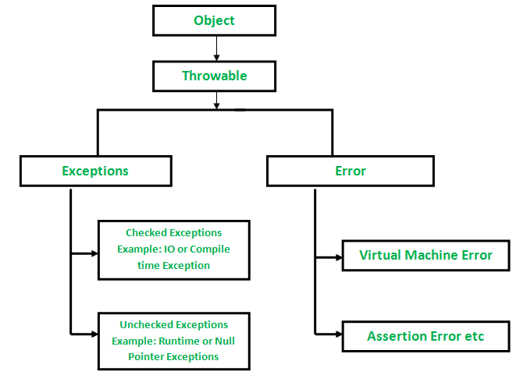

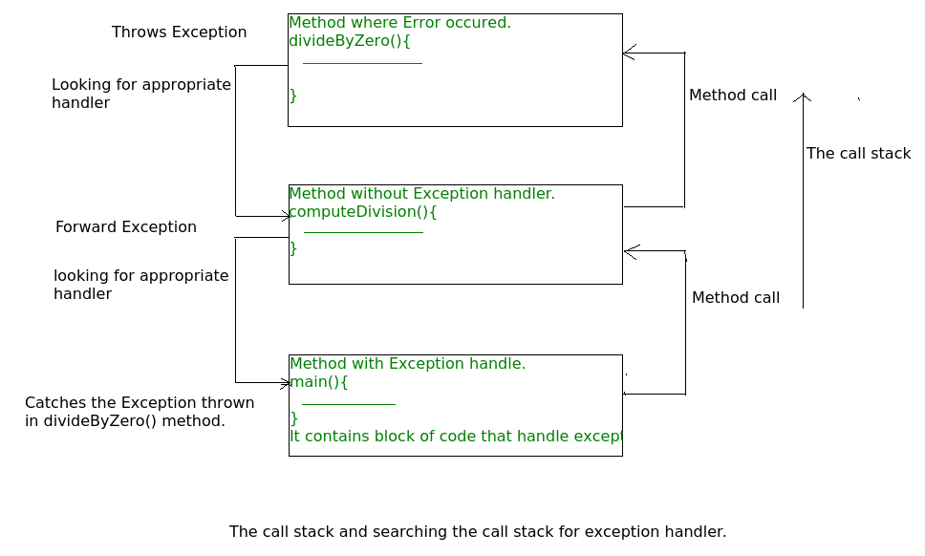

# Question 1

Predict the output of following Java program

|  |
| --- |
| class Main {     public static void main(String args[]) {        try {           throw 10;        }        catch(int e) {           System.out.println("Got the  Exception " + e);        }    }  } |

Run on IDE

**(A)** Got the Exception 10  
**(B)** Got the Exception 0  
**(C)** Compiler Error  
  
  
**Answer:** **(C)**

**Explanation:** In Java only throwable objects (Throwable objects are instances of any subclass of the Throwable class) can be thrown as exception. So basic data type can no be thrown at all.

# Question 2

class Test extends Exception { }

class Main {

   public static void main(String args[]) {

      try {

         throw new Test();

      }

      catch(Test t) {

         System.out.println("Got the Test Exception");

      }

      finally {

         System.out.println("Inside finally block ");

      }

  }

}

**(A)**

Got the Test Exception

Inside finally block

**(B)**

Got the Test Exception

**(C)**

Inside finally block

**(D)** Compiler Error  
  
  
**Answer:** **(A)**   
  
**Explanation:** In Java, the finally is always executed after the try-catch block. This block can be used to do the common cleanup work. There is no such block in C++.

# Question 3

class Base extends Exception {}

class Derived extends Base  {}

public class Main {

  public static void main(String args[]) {

   // some other stuff

   try {

       // Some monitored code

       throw new Derived();

    }

    catch(Base b)     {

       System.out.println("Caught base class exception");

    }

    catch(Derived d)  {

       System.out.println("Caught derived class exception");

    }

  }

}

# Caught base class exception (B) Caught derived class exception (C) Compiler Error because derived is not throwable (D) Compiler Error because base class exception is caught before derived class Answer: (D)

# Questions:

# 1) What is Exception in Java?

# 2) What is difference between Checked and Unchecked Exception in Java ?

# 3) What is similarity between NullPointerException and ArrayIndexOutOfBoundException in Java?

# 4) What best practices you follow while doing Exception handling in Java ?

# 6) What is difference between throw and throws keyword in Java?

# 7) What is Exception chaining in Java?

# 8) Have you written your own custom Exception in Java? How do you do that?

# 9) What changes has been introduced in JDK7 related to Exception handling in Java ?

# 10) Have you faced OutOfMemoryError in Java? How did you solved that?

# 11) Does code form finally executes if method returns before finally block or JVM exits ?

# 12) What is difference in final, finalize and finally keyword in Java?

# Read more: https://javarevisited.blogspot.com/2013/06/10-java-exception-and-error-interview-questions-answers-programming.html#ixzz5J2cUApBC